# How to use your Genuair inhaler

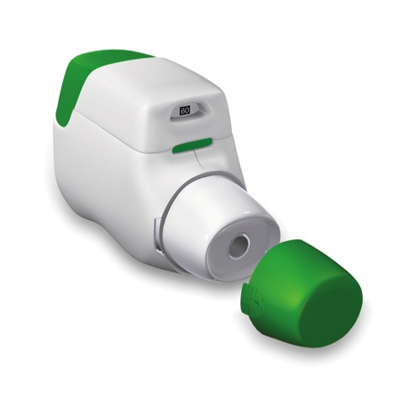**Inhalers are commonly prescribed for patients with asthma and chronic obstructive pulmonary disease (COPD) as they are very effective at delivering the medication straight to the lungs where it is needed.**

Using your inhalers correctly is an important part of asthma or COPD treatment. You should be shown how to use inhalers properly by a healthcare professional when they are first prescribed.

You may occasionally experience problems using your inhalers, especially if it has been a while since you were shown the correct technique. This is very common and your healthcare professional can help you improve your inhaler technique.

## Why is inhaler technique important?

* It allows the correct dose of medication to reach your lungs.
* It gives you better control of your condition.

|  |  |
| --- | --- |
| Examples of Genuair inhalers | Eklira Genuair |
| Duaklir Genuair |

## Checklist for Genuair use

|  |  |
| --- | --- |
| **1** | Stand or sit upright when using your Genuair inhaler. |
| **2** | Remove the protective cap from the mouthpiece by lightly squeezing the arrows on each side of the cap and pulling it off. Hold the Genuair inhaler horizontally with the mouthpiece towards you and the coloured button facing up. |
| **3** | Press the coloured button all the way down and then release it, do not keep it held down. |
| **4** | Check the control window above the mouthpiece has changed to green. This confirms that the medicine is ready for inhalation. |
| **5** | Breathe out gently as far as is comfortable, away from the mouthpiece. Do not breathe in again yet. |
| **6** | Place the mouthpiece between your teeth without biting and form a good seal around it with your lips. |
| **7** | Breathe in strongly and deeply. While you breathe in you should hear a “click”. This means that you are using the Genuair inhaler correctly. |
| **8** | Keep breathing in even after you have heard the inhaler “click” to be sure you get the full dose. |
| **9** | Remove the Genuair inhaler from your mouth and hold your breath for about ten seconds or as long as is comfortable, then breathe out slowly through your nose. |
| **10** | Replace the protective cap on the mouthpiece. |

## Common problems

Common mistakes that people make with Genuair inhalers include:

* Not standing or sitting up to take the Genuair inhaler.
* Not holding the Genuair inhaler upright when using it.
* Not pressing the coloured button all the way down. If the control window does not turn green, you have not pressed the button firmly enough and you should try again.
* Not releasing the coloured button but continuing to hold it down.
* Not inhaling strongly and deeply enough to draw the medication out of the Genuair inhaler and in to the lungs.
* Holding the coloured button down whilst inhaling.
* Not holding your breath long enough after breathing in the contents.
* Breathing out through the Genuair inhaler (remove the Genuair inhaler from your mouth first).
* Not replacing the protective cap on the mouthpiece.

## Useful tips

* Before first use, tear the sealed pouch along the notch and remove the Genuair inhaler.
* Always check that nothing is blocking the mouthpiece.
* If the window above the mouthpiece remains red after pressing and releasing the coloured button, then press and release the coloured button again.
* Make sure the coloured button is released before inhaling.
* You may notice a taste when you inhale the medicine.
* Check the control window has turned to red after inhaling. This confirms that the full dose was inhaled correctly. If the window is still green inhale strongly and deeply through the mouthpiece again.
* Always replace the protective cap on the mouthpiece after use.

# How did I do?

|  |
| --- |
|  |

## For video demonstrations on how to use your inhaler visit:

<https://player.vimeo.com/video/178617775>

## Ensure that you have your respiratory condition and inhaler technique reviewed at least annually